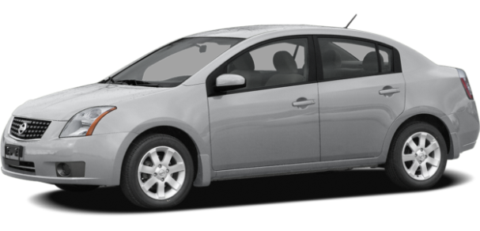

|  |  |
| --- | --- |
| **VEHÍCULO** | Platina |
| **MODELO** | 2006 |
| **COMBUSTIBLE** | Gasolina |
| **PLACAS** | 880-TZA |
| **NO CIRCULA VIERNES** | |

|  |  |  |  |  |  |  |  |  |  |
| --- | --- | --- | --- | --- | --- | --- | --- | --- | --- |
| **ID** | **Nombre del comisionado** | **Destino** | **Fecha** | | **Combustible** | | **Kilometraje** | | **Firma** |
| **Salida** | **Entrada** | **($)** | **(L)** | **Inicial** | **Final** |
| 01 |  |  |  |  |  | |  |  |  |
| 02 |  |  |  |  |  | |  |  |  |
| 03 |  |  |  |  |  | |  |  |  |
| 04 |  |  |  |  |  | |  |  |  |
| 05 |  |  |  |  |  | |  |  |  |
| 06 |  |  |  |  |  | |  |  |  |
| 07 |  |  |  |  |  | |  |  |  |
| 08 |  |  |  |  |  | |  |  |  |
| 09 |  |  |  |  |  | |  |  |  |
| 10 |  |  |  |  |  | |  |  |  |
| 11 |  |  |  |  |  | |  |  |  |
| 12 |  |  |  |  |  | |  |  |  |
| 13 |  |  |  |  |  | |  |  |  |
| 14 |  |  |  |  |  | |  |  |  |
| 15 |  |  |  |  |  | |  |  |  |
| 16 |  |  |  |  |  | |  |  |  |
| 17 |  |  |  |  |  | |  |  |  |
| 18 |  |  |  |  |  | |  |  |  |
| 19 |  |  |  |  |  | |  |  |  |
| 20 |  |  |  |  |  | |  |  |  |
| 21 |  |  |  |  |  | |  |  |  |

|  |  |
| --- | --- |
| **ID** | **Observaciones** |
| 01 |  |
| 02 |  |
| 03 |  |
| 04 |  |
| 05 |  |
| 06 |  |
| 07 |  |
| 08 |  |
| 09 |  |
| 10 |  |
| 11 |  |
| 12 |  |
| 13 |  |
| 14 |  |
| 15 |  |
| 16 |  |
| 17 |  |
| 18 |  |
| 19 |  |
| 20 |  |
| 21 |  |